1. Firstly, I Have Created a database and hardcoded some values to it.

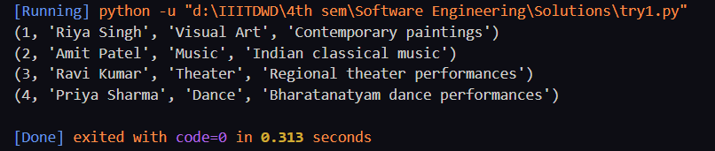

1. Next, I have Generated a code Using ChatGPT to create a GUI to “ENTER” the Details.

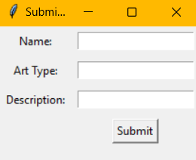

After Entering The values,

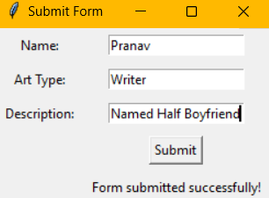

1. Next, I have Generated a code Using ChatGPT to create a GUI Which “FETCH” all the Details in the database by sorting them in id values.

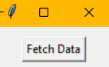

After Pressing The Button “Fetch Data”,

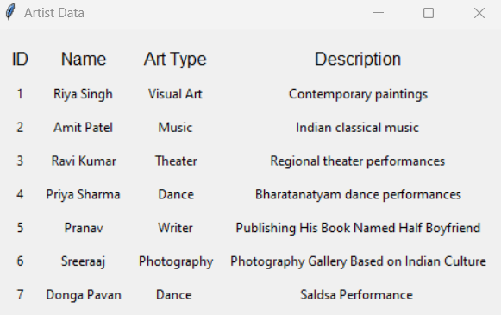

1. Next, I have Generated a code Using ChatGPT to create a GUI to “SORT” the Database according to their respective artforms.

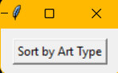

After Clicking the Button “Sort by Art Type”,

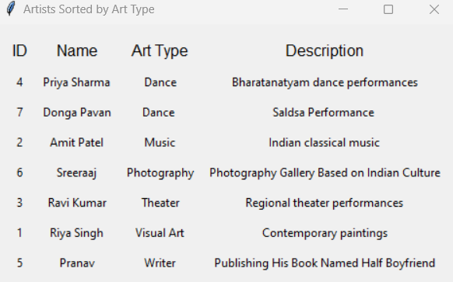

1. Next, I have Generated a code Using ChatGPT to create a GUI Which helps me to “EDIT” the details if there are any mistakes while I entered data.

Here I Have entered Saldsa Instead of Salsa,

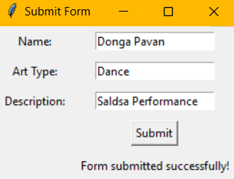

So, After Running the Code,  
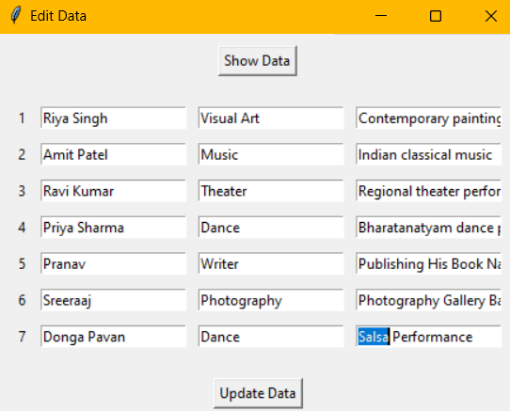

After Editing again, I have fetched the data

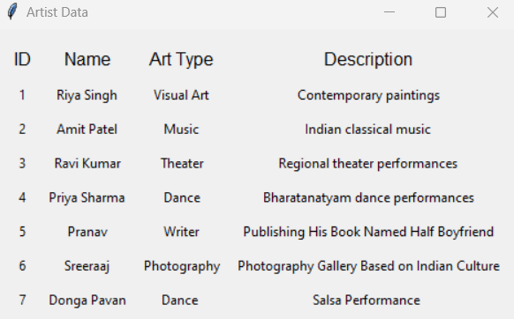

As we can See the Data Has Been Updated

1. Next, I have Generated a code Using ChatGPT to create a GUI Which helps me to “Delete” the details of a person and sort the id’s accordingly.

Here I have deleted the data of “Priya Sharma”

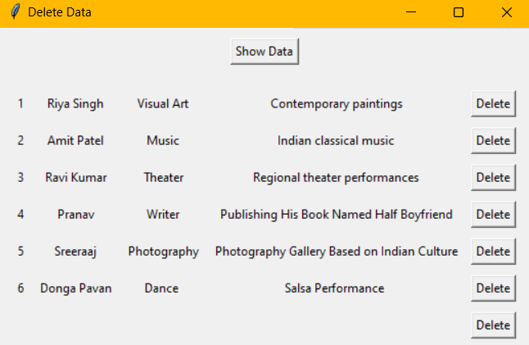

Fetching Again After Deleting A row,

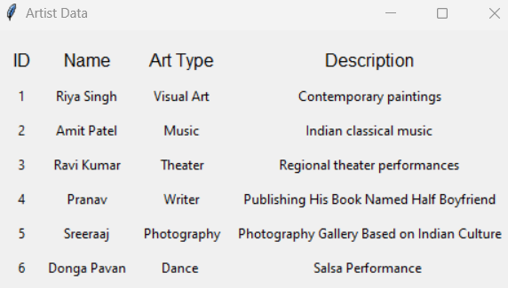

As we can See the Data Has Been Updated